

Software Engineering Department
Braude College of Engineering
Capstone Project – Phase B

Data Imbalance Testing and Handling System
CODE: 26-1-D-3
By:
Niv Oren
Daniel Levovsky

Advisor:
Dr. Avital Shulner Tal

Link to GitHub:
https://github.com/Niv0902/Niv-and-Dani---Data-Imbalance-Testing-and-Handling-System

1.Introduction
Many real-world classification datasets have far fewer examples of one class than others. In these cases, a model can look good on overall accuracy while still failing on the rare class that often matters most (for example: fraud, faults, or medical events). In practice, dealing with imbalance data is often done across different tools, with different metrics, and without clear documentation of what was changed, which makes it harder to compare and repeat. In recent years, rapid progress in science and technology has led to the collection of massive amounts of data. However, this data is often not distributed evenly. This uneven distribution results in what is known as the class imbalance problem [Niaz et al. 2022] a phenomenon where the distribution of labels within a dataset is significantly skewed, resulting in biased and discriminated outputs. Because of this, models often become less accurate and reliable [Johnson & Khoshgoftaar, 2019], particularly in critical applications where accurate predictions for minority classes are top priority, such as fraud detection, medical diagnosis and security analysis [Hida & Nascimento, 2025]. . There have been several methods developed to handle the imbalance problem, one of which is called sampling (re-sampling) [Nikpour et al., 2026]. Sampling techniques, also referred to as data preprocessing methods, involve manually re-adjusting the dataset's composition. This balance is achieved in two primary ways: by undersampling the majority class or oversampling the minority class, though it is also possible to combine both strategies for a hybrid approach. Oversampling involves increasing the frequency of specific data points by duplicating them or creating synthetic versions to give those points more weight, In contrast, Undersampling involves selecting only a subset of available data points and discarding the rest to reduce the overall volume of a specific group within a dataset [Longadge et al, 2013].
Our project presents a data balancing system designed for AI researchers and developers who need better control and transparency when handling imbalanced datasets. The system analyzes the dataset, identifies overrepresented and underrepresented labels, calculates an imbalance score before and after balancing, and allows the user to choose between different balancing methods. Unlike many existing tools, our system focuses not only on producing a balanced dataset, but also on clearly showing how the dataset changed and enabling comparison between methods.

2.Background and related work
Imbalanced data classification is a problem in which proportional class sizes of a dataset differ relatively by a substantial margin. In this, one class is at least depicted with just a fewer samples (e.g., the minority class) and the rest fall into the other class (e.g., the majority class)[KAUR et al., 2019].
There are several measurements for calculating the imbalance degree of a dataset [Nikpour et al., 2026]. For example, a metric called Imbalance Ratio (IR) [Orriols-Puig & Bernadó-Mansilla, 2009] that is calculated by dividing the number of samples in the majority class (N-maj) to the number of minority class samples (N-min) as:
IR = N-maj / N-min.
High values of IR indicate a severe skew that complicates the learning process for most machine learning models. As noted by Haixiang et al. [2017], while almost all real-world datasets exhibit some degree of imbalance, the classification of minority samples remains a uniquely challenging task. This difficulty arises because classical classifiers are internally designed to assume an even distribution of data.
Assessment metrics serve as the primary indicators for gauging a machine learning model's effectiveness. Although standard accuracy and error rates are frequently utilized, they often provide a skewed perspective when dealing with imbalanced datasets because they assume classes are distributed evenly. In binary classification, a more reliable way to evaluate performance is by utilizing a Confusion Matrix [Niaz et al. 2022].
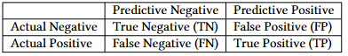
By utilizing these assessment metrics, [Shamsuddin & Ralescu, 2013, Niaz et al. ,2022] suggested another imbalance measurement called "The G-Mean"(geometric mean), is a metric used to show how well a classifier balances the accuracy between the positive and negative classes. By combining sensitivity (accuracy on the positive class) and specificity (accuracy on the negative class) into a single score, it measures overall balance. A low G-mean score indicates that the model is heavily biased toward one class, while a higher score shows that the model is performing well on both groups simultaneously. A complete list of additional assessment metrics is provided in Appendix A.
G-Mean =$\sqrt{\frac{TP}{TP+FN}*\frac{TN}{TN+FP}}$
Additionally, diagnosing a skewed dataset can be challenging due to a phenomenon called “The Accuracy Paradox” where high accuracy is not necessarily an indicator of high classifier performance [Valverde-Albacete & Peláez-Moreno, 2014]. In cases where classes are imbalanced, looking at overall accuracy can be very misleading. Imagine a dataset with 5,000 records where 99% belong to the majority group and only 1% belong to the minority. If a model fails to identify even a single minority case, it will still show a 99% accuracy rate. We can demonstrate it by applying the formula for accuracy computation as provided in Appendix A: (4,950 + 0) / (4,950 + 0 + 50 + 0). The core goal when working with imbalanced datasets is to successfully detect the minority samples. In the 99% accuracy example mentioned earlier, the model achieves a high score by simply ignoring the minority group altogether. [Rezvani & Wang, 2023].
Consequently, when Artificial Intelligence models are trained on datasets with a high Imbalance Ratio, they run a significant risk of misclassifying the minority cases which are the very samples that typically carry the highest importance or risk. This is not merely a mathematical oversight; it is a critical vulnerability that transforms statistical skew into real-world failure. When an algorithm is "blind" to the minority class, the resulting errors can manifest as systemic biases that disproportionately affect underrepresented groups or lead to catastrophic oversights in high-stakes environments. A landmark example of this phenomenon is documented by [Buolamwini & Gebru, 2018] who revealed that commercial facial recognition systems from major providers like IBM and Microsoft suffered from a profound "gender gap," with error rates reaching nearly 35% for darker-skinned women compared to less than 1% for lighter-skinned men. This disparity was a direct consequence of dataset imbalance, as the "state-of-the-art" training sets were heavily skewed toward lighter-skinned, male faces. Ultimately, because these groups were treated as a statistical minority in the training data, the models effectively dismissed their unique features as "noise," resulting in high failure rates for those individuals in real-world deployments.
Given the ethical risks and the deceptive nature of the accuracy paradox, remediating class imbalance has become a primary focus in machine learning research. The need for accurate minority representation has driven the development of specialized algorithms and automated software. The following sections review these state-of-the-art methodologies and evaluate existing tools currently available to practitioners.
2.1 Methodologies for Balancing
The data-level approach, often called an external technique, uses a pre-processing step to fix the balance of the dataset before the model ever sees it. This is usually done through under-sampling or over-sampling to lower the imbalance ratio. Under-sampling works by removing examples from the majority group to close the gap between classes, while over-sampling increases the size of the minority group by duplicating its examples or creating new ones. [Shamsuddin & Ralescu, 2013].
2.1.1 Over-sampling: Synthetic Minority Over-sampling Technique (SMOTE)
Synthetic Minority Over-sampling Technique (SMOTE) [Chawla et al., 2002] is a widely used method designed to balance datasets by generating new minority samples through interpolation. It works by identifying the k-nearest neighbors for each minority sample and then randomly selecting specific neighbors based on the amount of over-sampling needed. New, "synthetic" data points are then created along the lines connecting the original sample to these neighbors. While SMOTE is effective for many problems, it faces a few significant challenges. Because it generates these new samples without considering the overall structure of the data, it can lead to overgeneralization, where the model becomes too broad in its predictions. Additionally, since the algorithm doesn't account for the location of the majority class, it can accidentally create new samples that bleed into the majority class's territory, causing class overlapping. This makes it harder for the model to clearly distinguish where one group ends and the other begins.[Nikpour et al., 2026].
2.1.2 Under-sampling: NearMiss Approach
NearMiss is a collection of four under-sampling techniques that use specific rules to select which majority samples to keep [Mani & Zhang, 2003]. Instead of removing data randomly, these methods use the distance between points to balance the dataset:
NearMiss-1: Keeps majority samples that are closest, on average, to their three nearest minority neighbors.
NearMiss-2: Keeps majority samples that have the smallest average distance to their three farthest minority neighbors.
NearMiss-3: Keeps a specific number of majority samples that are closest to every individual minority sample, ensuring each minority point is "surrounded" by some majority data.
Most Distant: Keeps majority samples that are the furthest away from their three closest minority neighbors, focusing on the "safest" data points far from the class boundary [Nikpour et al., 2026].
Even though these methods use smart rules to pick which data to keep, they still face the same big problem as any strategy that deletes data. “The elimination of examples (down-sampling) from a class could lead to loss of potentially important information about the class” [Shamsuddin & Ralescu, 2013].
In contrast to these data-centric modifications, the algorithm-level methods could be categorized as dedicated algorithms that directly learn the imbalance distribution from the classes in the datasets [Shamsuddin & Ralescu, 2013].
2.2 Existing Tools and Software
There are several existing tools that can balance imbalanced datasets. For example: Imbalanced-learn is the industry-standard Python library specifically designed to address class imbalance. It is an open-source project, part of the scikit-learn-contrib ecosystem, and is widely cited in academic research for its robust implementation of resampling algorithms.
The package smote-variants provides a python implementation of 85 over-sampling methods (Kovács, 2019b). This package provides multi-class compatible with 61 of the implemented binary over-sampling methods. It also includes a model selection framework that makes it easy to find the suitable over-sampling method for a specific dataset [Nikpour et al., 2026].
Another tool is WEKA (Waikato Environment for Knowledge Analysis). Weka is one of the most established open-source platforms for data mining and machine learning. Developed by the University of Waikato, it is a Java-based GUI tool that allows users to perform complex data balancing tasks without writing a single line of code. WEKA presents two solutions. First, to carry out a training data re-balancing. Second, perform a cost-sensitive classification. We selected the re-balancing procedure via instance filtering methods. Besides these, we can include the SMOTE preprocessing via the package manager [Rezvani & Wang, 2023].
The KEEL repository is a widely recognized digital library specifically designed to help researchers benchmark machine learning algorithms. It is particularly valuable for the study of imbalanced datasets, as it provides a standardized —such as oversampling or undersampling—on consistent, "real-world" problems to see which approach works best for detecting the minority class. In addition to providing a data repository, KEEL offers a comprehensive open-source software tool designed for various data mining tasks [Triguero et al., 2017]. The software features a specialized module for imbalanced learning, which includes several popular data-level algorithms that are easy to implement. To ensure scientific rigor, KEEL also provides a full suite of statistical procedures, including both parametric and non-parametric tests, allowing researchers to perform reliable pairwise comparisons between different algorithms [Nikpour et al., 2026].

3. System Overview and Architecture

3.1 General Description
ImbalanceKit is a web-based, wizard-driven application designed to assist users in diagnosing, handling, and evaluating class imbalance in tabular datasets. The system guides the user through a structured nine-step process — from uploading a dataset, through selecting a target label column, validating data quality, diagnosing the degree of imbalance, applying a chosen balancing method, and finally reviewing and exporting the results. The application is built on a client-server architecture, with a React-based frontend communicating with a FastAPI backend via a REST API. All processing is performed in-memory, making the system lightweight and easy to deploy without the need for a database or persistent storage infrastructure. The balancing pipeline runs in a background thread and is polled in real time by the frontend, providing the user with live progress feedback throughout the process.

The primary goal of ImbalanceKit is to make class imbalance handling accessible, transparent, and reproducible. The system implements three widely-used balancing strategies — SMOTE (Synthetic Minority Oversampling Technique), NearMiss (undersampling), and a Combined approach that applies both — allowing users to compare their effects on class distribution and imbalance ratio before and after processing. A core objective of the system is to ensure methodological correctness: balancing is applied exclusively to the training portion of the data, preserving the integrity of the held-out set. The system also aims to provide clear visual feedback through before-and-after class distribution charts and quantitative metrics, enabling informed decision-making rather than blind application of balancing techniques. Additionally, the system supports exporting the balanced dataset as a CSV and generating a structured PDF summary report, making results easy to integrate into downstream workflows.

ImbalanceKit is designed to serve a broad audience of data-oriented professionals and learners who encounter class imbalance as part of their work. Machine learning researchers and AI developers are a primary audience — these users frequently work with real-world datasets where class imbalance is a natural occurrence, and require reliable, reproducible preprocessing tools that integrate into their experimental pipelines. Data scientists working in applied domains such as healthcare, fraud detection, and risk assessment will find the system particularly useful, as these fields are characterized by severe imbalance between event and non-event classes. Students and academic users form another key segment — the wizard-style interface and step-by-step guidance make the system suitable for learning and demonstrating the practical impact of balancing methods without requiring prior familiarity with the underlying libraries. Finally, professional researchers conducting comparative studies on imbalance-handling techniques can use ImbalanceKit as a controlled experimentation environment, running multiple balancing configurations on the same dataset and comparing outcomes side by side through the run history feature.

3.2 System Architecture
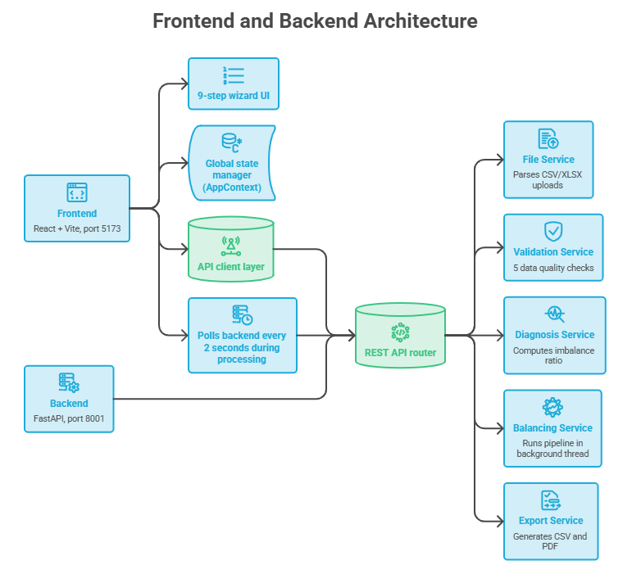
Figure 1. System architecture showing the React frontend communicating with the FastAPI backend services through a REST API router.

ImbalanceKit follows a classic client-server architecture, separating the user interface from the
processing logic into two independently running components. The frontend, built with React and Vite, runs on port 5173 and presents the user with a nine-step wizard interface. It maintains global application state through a context manager and communicates with the backend exclusively through a REST API client layer. During the balancing process, the frontend polls the backend every two seconds to retrieve live progress updates and display them to the user in real time. The backend, built with FastAPI and running on port 8001, receives incoming requests and routes them through a set of dedicated services: the File Service handles parsing of uploaded CSV and XLSX files, the Validation Service performs five data quality checks on the dataset, the Diagnosis Service computes the imbalance ratio and class distribution, and the Balancing Service executes the full preprocessing pipeline, applying the selected balancing method (SMOTE, NearMiss, or Combined), and computing before-and-after statistics. The balancing pipeline runs in a background daemon thread to avoid blocking the API, and its results are stored in a thread-safe in-memory state store alongside the uploaded dataset. Once processing is complete, the Export Service makes the results available for download as a balanced CSV file, a PDF summary report, or a ZIP archive containing both. The system requires no database or persistent storage, making it lightweight and straightforward to deploy.
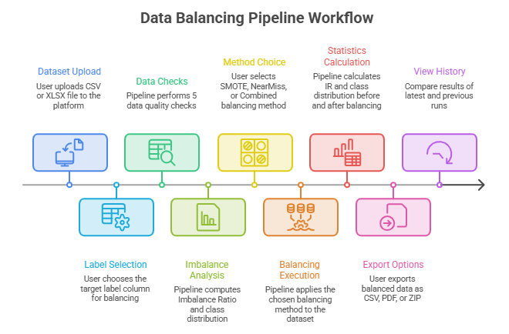
3.3 System User Interaction

Figure 2. The nine-step data balancing pipeline, from dataset upload through balancing to results export and comparing runs.

The ImbalanceKit pipeline follows a linear, wizard-driven workflow that takes the user from raw data to a balanced, exportable dataset in a structured sequence of nine steps. The process begins with the user uploading a CSV or XLSX file, after which they select the target label column they wish to balance. The system then performs five automated data quality checks to ensure the dataset meets the minimum requirements for processing. Following these checks, the pipeline analyzes the class distribution and computes the Imbalance Ratio, giving the user a clear quantitative picture of the severity of the imbalance. The user then chooses a balancing method, either SMOTE, NearMiss, or Combined, and the pipeline executes the selected method on the dataset. Once balancing is complete, the system calculates the updated Imbalance Ratio and class distribution, producing a before-and-after comparison of the data. These results are presented to the user through interactive charts and a sample count table, allowing direct visual comparison of the dataset before and after balancing. The user can then export the balanced dataset as a CSV file, a PDF summary report, or both together in a single ZIP archive. Finally, the View History step lets the user compare the results of the latest run against previous runs, supporting side-by-side evaluation of different balancing configurations on the same dataset.

4.Research and Development Process
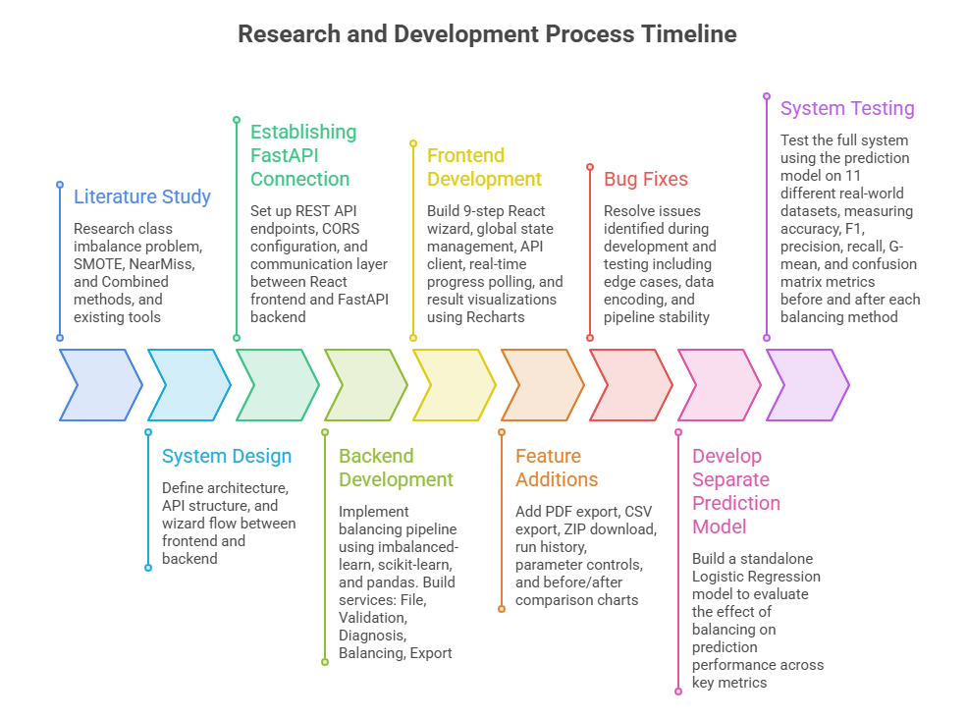
4.1 Development Stages

Figure 3. Timeline of the research and development process, from literature study to final system testing.

The development of ImbalanceKit followed a structured, iterative process that began with an in-depth study of the literature surrounding class imbalance, reviewing the theoretical foundations of SMOTE, NearMiss, and Combined balancing strategies, as well as surveying existing tools and their limitations.
Development started by establishing the REST API communication layer between the React frontend and FastAPI backend, after which the backend services were built sequentially: file parsing, data validation, imbalance diagnosis, the balancing pipeline, and the export service. The frontend was then constructed as a nine-step wizard with real-time progress polling, interactive result charts, and run history. Features were added incrementally throughout the cycle, including PDF report generation, CSV and ZIP export, and before-and-after comparison visualizations, with bug fixes applied continuously as edge cases emerged.
In the final phase, a standalone Logistic Regression prediction model was developed and tested against eleven real-world datasets to empirically validate the effect of each balancing method on key performance metrics including accuracy, F1-score, precision and G-mean.

4.2 Tools and Technologies Used

The backend of ImbalanceKit was developed in Python 3.13 using FastAPI as the web framework, with pandas for data manipulation, scikit-learn for data splitting and preprocessing, and imbalanced-learn for the core balancing algorithms, SMOTE, NearMiss, and the Combined approach. ReportLab was used to generate the PDF summary export. The frontend was built with React and Vite, using Recharts for interactive data visualizations, react-router-dom for navigation between wizard steps, and Axios for HTTP communication with the backend. Development was carried out in Visual Studio Code, with Git and GitHub used for version control and collaboration between the two team members. The pytest framework was used for backend unit testing, covering the core balancing logic across a wide range of scenarios and edge cases. For the prediction model used in system evaluation, scikit-learn's Logistic Regression implementation was used alongside standard classification metrics to measure the impact of balancing across eleven real-world datasets.

4.3 implementation and design decisions

While the previous section explained how the balancing methods work conceptually, putting them into practice required concrete engineering decisions: selecting libraries, setting algorithm parameters, and establishing the execution order for the Combined strategy.

Instead of blindly relying on default library settings, every choice was grounded in foundational academic research and verified through our own parameter sensitivity tests.

4.3.1 Synthetic Minority Over-sampling Technique

SMOTE balances a dataset not by copying existing minority rows but by creating brand-new rows that look realistic, blending pairs of existing ones to fill the gaps between minority samples and give a richer picture of what the minority class looks like. An extended explanation of how SMOTE works is provided in Appendix C.

As Chawla et al. (2002) explain, "SMOTE over-samples the minority class by taking each minority class sample and introducing synthetic examples along the line segments joining any or all of the k minority class nearest neighbors."

The number of neighbors used for this interpolation, k = 5, was chosen based on the original research paper, whose authors tested the method on multiple real-world datasets and found that k = 5 consistently produced the best balance between two competing risks: if k is too small the synthetic points cluster too tightly around existing points and add little variety, while if k is too large the algorithm interpolates between distant minority samples and may place points inside majority-class territory, introducing noise. As Chawla et al. (2002) note, k = 5 "allows for enough diversity in the synthetic samples while keeping interpolation local enough to remain representative of the minority class." This value was adopted as the standard default in the imbalanced-learn library, which our tool uses, and our own parameter sensitivity tests confirmed it , changing k from 3 to 15 produced identical results on our datasets, showing that k = 5 is both theoretically justified and practically stable.

4.3.2 NearMiss

NearMiss works in the opposite direction from SMOTE. Instead of adding new rows to the minority class, it removes rows from the majority class until both classes are equal in size. Nothing new is created. Every row in the output is a real original row.
The key question NearMiss has to answer is which majority rows to keep and which to remove. As Zhang and Mani (2003) describe, "NearMiss-1 selects samples from the majority class for which the average distance to the k nearest samples of the minority class is the smallest." In other words, the majority rows sitting closest to the minority boundary are kept, and the rest are removed. An extended explanation of how NearMiss works is provided in Appendix D.

The value n=3 comes directly from the original NearMiss paper. As confirmed by a 2025 review published in the Journal of Big Data, "NearMiss-1 provides for removing majority samples whose average distance to the k-nearest neighbors of the minority class is the smallest, where the original article used k=3" (Leevy et al., 2025).

The reason the original authors chose 3 follows the same logic as k=5 in SMOTE. The value of n=1 makes the selection too sensitive to individual outliers. A large value makes the average too broad and the algorithm loses precision. The value 3 balances stability and precision and has been used as the standard default in the imbalanced-learn library ever since.

Our parameter sensitivity tests confirmed this. Changing n from 1 to 10 always produced the same final class counts and the same IR of 1.0, showing that n=3 is a safe and well justified default for our tool.

In our NearMiss parameter sensitivity report, we used the Jaccard index to measure how much overlap there was between the set of majority rows kept by the default n=3 and the sets kept by other n values (1, 5, 7, 10). For each n value, we compared which rows NearMiss selected against the rows selected at n=3, and calculated J(A,B) where A and B are the two sets of kept row indices.

For example, a Jaccard score of 0.79 at n=1 means that 79% of the rows selected at n=1 were the same rows selected at n=3. A score of 0.91 at n=5 means 91% overlap with n=3. Additional explanation on the Jaccard index can be found in Appendix E.

4.3.3 Combined Method (SMOTE + NearMiss)

Combined runs SMOTE and NearMiss one after the other. First it calculates the halfway point between the two class sizes. For example, with 500 majority and 268 minority the midpoint is 384. SMOTE grows the minority class up to 384, then NearMiss shrinks the majority class down to 384. Both classes meet in the middle.
This is smarter than running either method alone. SMOTE on its own can create synthetic rows that accidentally land inside majority class territory, adding noise near the boundary. NearMiss on its own removes real data permanently, which means losing information. Combined limits both risks at the same time. Fewer synthetic rows are created, and fewer real rows are removed, while NearMiss cleans up the majority side after SMOTE runs, pushing the boundary between the two classes to be cleaner and more reliable.
This is backed by research. A study published in Springer BMC Medical Informatics, which tested hybrid sampling on the Pima Indians Diabetes dataset, the same dataset we use, found that the hybrid approach was significantly better than using either method alone. The authors describe the same order we follow: "firstly, the SMOTE is used to over-sampling the datasets, so that the number of samples of the two classes is balanced. Then, ENN is used to under-sampling the over-sampled dataset to delete the noisy sample in the majority" (Zhang et al., 2022). An extended explanation of why we used SMOTE before NearMiss is provided in the appendix F.

Example: 1000 Majority vs 500 Minority:
Consider a dataset with 1000 majority rows and 500 minority rows, giving an IR of 2.0. Here is what each method does.
SMOTE leaves the 1000 majority rows untouched and generates new synthetic minority rows. For each minority row, it finds its 5 most similar minority neighbors, picks one, and creates a new row somewhere between the two. For example, if one minority row has age=30 and another has age=40, the synthetic row might have age=34. It repeats this until the minority class reaches 1000. The final dataset has 1000 majority and 1000 minority rows (2000 total), with the 500 new synthetic rows flagged with 0.

NearMiss leaves the 500 minority rows untouched. For each of the 1000 majority rows, it calculates the average distance to its 3 nearest minority rows, then keeps the majority rows sitting closest to the minority class and removes those farthest away. It continues until the majority also reaches 500. The final dataset has 500 majority and 500 minority rows (1000 total), with all 500 removed rows saved in the changes-log CSV.

Combined first calculates the midpoint: (1000 + 500) / 2 = 750, the target for both classes. SMOTE runs first, growing the minority from 500 to 750 by creating 250 synthetic rows as described above. NearMiss then examines the 1000 majority rows, measuring each one's distance to its 3 nearest minority neighbors, which now include both the original 500 and the 250 synthetic rows. It keeps the 750 majority rows closest to the boundary and removes the other 250. The final dataset has 750 majority and 750 minority rows (1500 total): 250 rows added by SMOTE (flagged with 0) and 250 majority rows removed by NearMiss (saved in the changes-log CSV).
5. System Testing
5.1 Experiment Overview

To evaluate the practical impact of ImbalanceKit's balancing methods, a standalone prediction model was applied to eleven real-world datasets across three domains: five in medical, three in finance, and three in education. All shared a common binary target label, gender, keeping the comparison consistent. Each dataset was processed three times, with SMOTE, NearMiss, and the Combined method, producing 44 runs including the original unbalanced baseline. The model ran on both the original and each balanced version, and the resulting metrics (accuracy, F1-score, precision, G-mean, and confusion matrix values) were recorded for comparison. The goal was to measure how class imbalance and its correction affect a model's ability to classify the target label across diverse real-world data.

5.2 Prediction Model

Logistic Regression is a statistical classification algorithm that models the probability of a binary outcome from one or more input features, making it one of the most widely used and interpretable baselines in machine learning. It was chosen for this experiment for its simplicity, stability, and well-established behavior, ensuring that any change in prediction performance could be attributed to the balancing method rather than model complexity. The model was configured with an 80/20 random train-test split.

Dataset | Gender (M / F) | IR | Description & Target Label
Credit Card Approval Prediction | 37.81% / 62.19% | 1.6448 | Applicant data predicting credit card approval. Target: application status (1 = approved, 0 = denied).
Adult Income | 66.85% / 33.15% | 2.0164 | Census data predicting whether an individual earns above a salary threshold. Target: income (1 = >50K, 0 = ≤50K).
Credit Card Default | 39.63% / 60.37% | 1.5236 | Taiwanese credit card clients predicting payment default. Target: default payment (1 = defaulted, 0 = did not).
5.3 Results
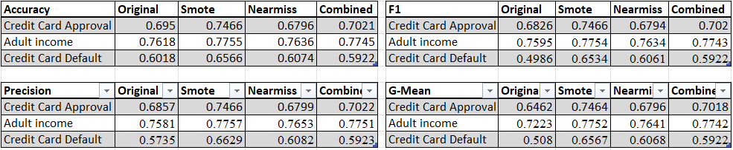

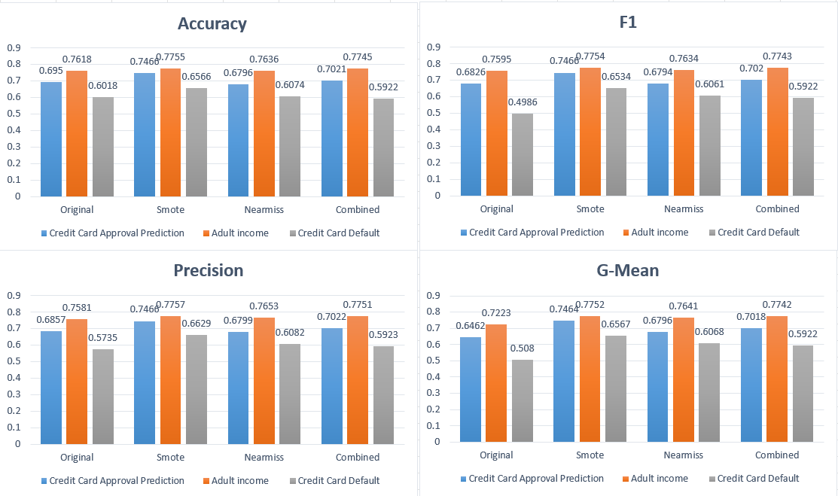

Dataset | Gender (M / F) | IR | Description & Target Label
Heart Disease | 67.99% / 32.01% | 2.1237 | Clinical data from Cleveland Clinic patients used to detect heart disease. Target: condition (1 = disease, 0 = none).
Cardiovascular Disease | 34.96% / 65.04% | 1.8606 | Predicts cardiovascular disease from patient health indicators. Target: cardio (1 = disease, 0 = none).
Stroke Prediction | 58.6% / 41.4% | 1.4156 | Predicts stroke likelihood from lifestyle and clinical features. Target: stroke (1 = had stroke, 0 = none).
Lung Cancer Diagnosis | 52.43% / 47.57% | 1.102 | Identifies lung cancer from patient symptoms and habits. Target: lung cancer (1 = cancer, 0 = none).
Indian Liver Patient Records | 75.64% / 24.36% | 3.1056 | Clinical data from India predicting liver disease from blood test results. Target: Dataset (1 = disease, 0 = none).
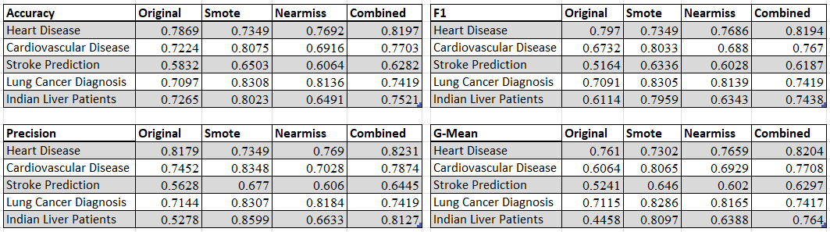

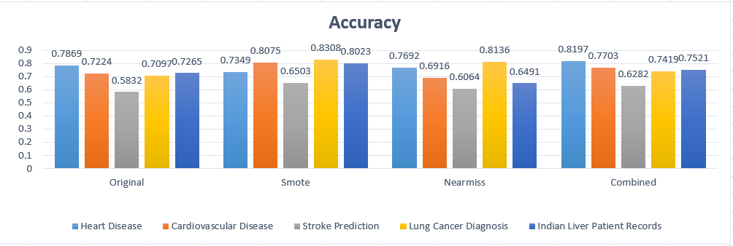

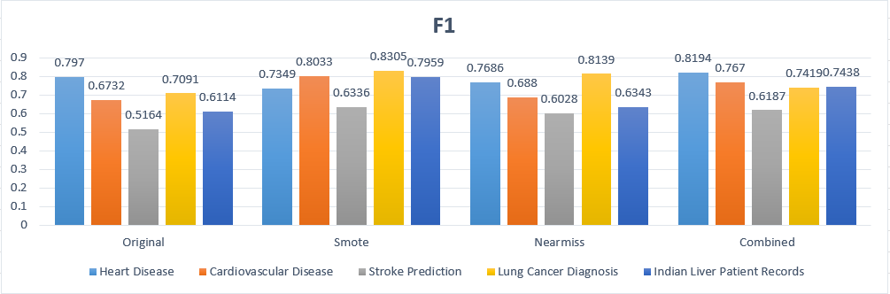

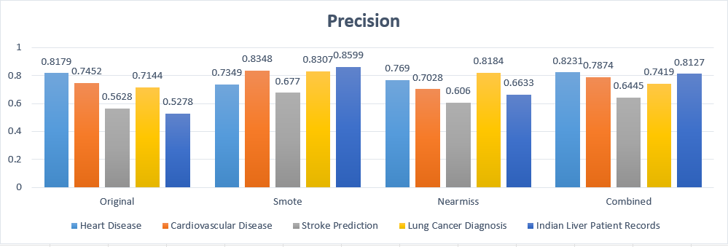

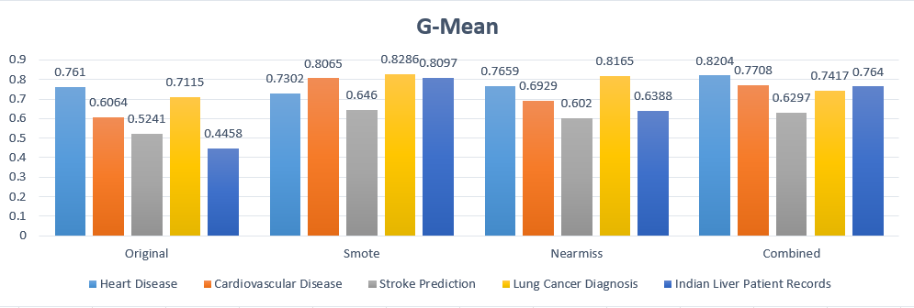

Dataset | Gender (M / F) | IR | Description & Target Label
Students Adaptability Level in Online Education | 55.02% / 44.98% | 1.2232 | Predicts students' adaptability level in online education. Target: Adaptivity Level (Low, Moderate, High).
Student Dropout Analysis and Prediction | 40.99% / 59.01% | 1.4398 | Predicts whether a student dropped out of higher education. Target: dropout (1 = dropped out, 0 = did not).
Student Performance | 47% / 53% | 1.1123 | Survey of secondary-school students in a math course. Target: G3 (final grade, 0–20).
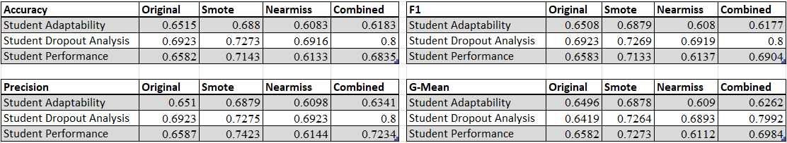

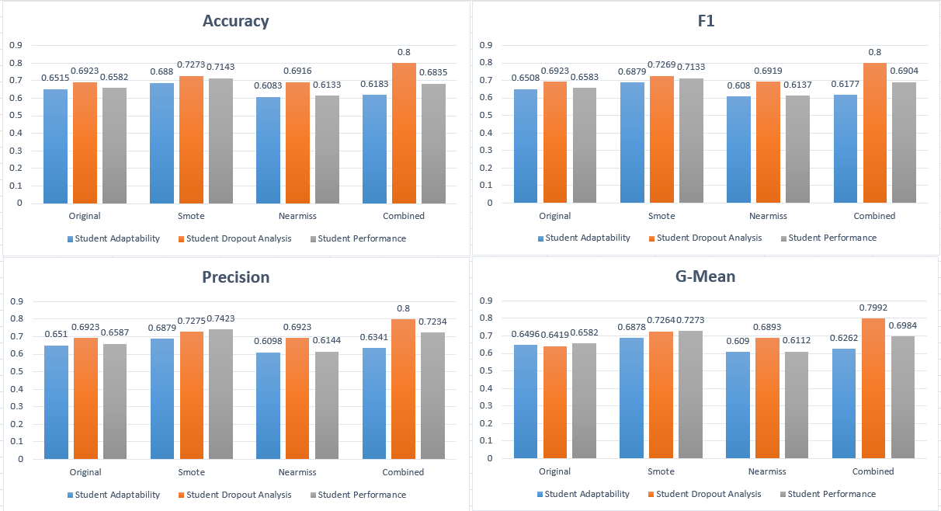

5.4 Analysis and Findings

Two methodological points should be stated up front. First, during data preparation the system compensates for missing feature values by filling them with the median of each column. The median was chosen over the mean because it is robust to outliers and skewed distributions, which are common in real-world datasets, ensuring that the imputed values do not distort the feature space before balancing is applied. Second, for the purpose of this experiment the entire dataset was balanced by each method before being passed to the prediction model, rather than balancing only a training partition. This is acceptable in this specific context because the goal of the experiment is not to produce a deployment-ready model but to compare each balanced dataset directly against the original, unbalanced version of itself under identical conditions. Since every method is measured against the same baseline using the same procedure, the comparison remains internally consistent, and the relative effect of each balancing method can be isolated.

Across all eleven datasets, balancing improved model performance in nearly every case, and the gains were largest on the metric that matters most. Average score across the datasets, SMOTE produced the strongest improvement over the original baseline, raising G-Mean by roughly +0.12, F1 by +0.08, and accuracy by +0.05 in average. The Combined method ranked second (G-Mean +0.09, F1 +0.06 in average), and NearMiss produced the smallest gains (G-Mean +0.05 in average) and was the only method that, on average, slightly reduced accuracy. On a per-dataset basis, SMOTE achieved the best G-Mean in nine of the eleven datasets, while the Combined method won the remaining two (Heart Disease and Student Dropout). NearMiss did not produce the best result on any dataset.
This pattern is consistent with the theory: SMOTE enriches the minority class by synthesizing new samples without discarding information, whereas NearMiss balances by deleting majority samples, necessarily removing potentially useful data. The Combined method sits between the two, gaining much of SMOTE's benefit while staying close to the original dataset size.

The strongest single illustration of why balancing matters is the Indian Liver Patient dataset, the most imbalanced in the set (IR = 3.11). On the original data the model reached an accuracy of 0.727, yet its confusion matrix shows TN = 0 and FN = 0, meaning it simply predicted the positive class for every patient and never identified the negative class at all. Its G-Mean of 0.446 exposes this failure that accuracy alone conceals. After SMOTE, true negatives rose from 0 to 57 and G-Mean climbed to 0.810, a textbook demonstration of the accuracy paradox discussed earlier and of balancing resolving it.

The results also show that balancing is not universally beneficial for every method. On the Students Adaptability dataset, SMOTE improved G-Mean (from 0.650 to 0.688), but both NearMiss and the Combined method slightly reduced it, and NearMiss likewise lowered G-Mean on Student Performance and Heart Disease. These cases reinforce that under-sampling carries a real risk of discarding informative samples, particularly on datasets that are only mildly imbalanced and have less data to spare.

In summary, the experiment provides clear quantitative evidence that data-level balancing improves a model's ability to classify both outcome classes, with the effect most pronounced on highly imbalanced datasets. SMOTE was the most effective method overall, the Combined method a strong and occasionally superior alternative, and NearMiss the least beneficial, sometimes carrying a slight cost due to its reliance on discarding data. Crucially, improvements in G-Mean and F1 repeatedly reveal value that raw accuracy conceals, reinforcing the central premise of this project.
6. Challenges and Conclusions

6.1 Challenges

Issue | Description | Resolution
Data Splitting | Whether the system should internally split the dataset into training and testing portions before balancing. Doing so reduces the samples available for balancing and could confuse users, expecting their full dataset back balanced. | The split was left to the user, who performs their own train-test split beforehand and feeds only the relevant portion. This keeps the system focused on its core purpose, balancing, without making assumptions about how the data is used downstream.
User Parameter Setting | Whether to let the user choose his own neighbor parameters during balancing (k for SMOTE and n for NearMiss) or fix them internally. Could potentially be confusing for non-experts and might produce unreliable output from poorly chosen values. | The parameters were fixed at the established defaults (k = 5 for SMOTE, n = 3 for NearMiss), drawn from the original research papers and confirmed by our own sensitivity tests, which produced identical results across a wide range of values
Synthetic Value Validity | By default, SMOTE generates synthetic rows through interpolation, which can produce values that are invalid for the column they belong to. It would assign decimal values to columns that can only hold integers, and positive-only or otherwise out-of-range values to columns with a restricted domain. For example, producing a fractional count where only whole numbers are meaningful, or a positive value in a column that should also permit negative ones. These unrealistic values undermine the integrity of the balanced dataset. | The code was extended to inspect each column before balancing, learning the data type and the valid range of values it contains. Using this information, the synthetic values generated by SMOTE are constrained to match the characteristics of each column
Logistic Regression Model | Two issues surfaced in the experiment code. First, the initial implementation was predicting the original target label rather than gender, the balanced label, so the model was being evaluated on the wrong target. Second, the 10-fold cross-validation used to evaluate the model proved too slow to run across all 44 datasets. | The code was refactored to predict the correct balanced label, and the tests were re-run. The 10-fold cross-validation was dropped after the first few results showed little variance in accuracy and the other metrics, making the added runtime cost unjustified.
Data pre-processing | Some datasets used to test the first iteration of the code could not be loaded, while others contained missing values that the balancing algorithms could not process. | A data validation step was added to catch problematic files early along with warning signs. The missing values were filled using the median of each column, ensuring the data was complete and compatible before balancing.
Website Deployment | The website was deployed using Vercel for the frontend and Render for the backend. On the free tiers of these services, the limited compute and memory resources cause very large datasets to take a long time to upload and process. | This limitation stems from the constraints of the free hosting plans rather than the system itself and was considered outside the scope of the final project. It was therefore left as a known limitation, which could be addressed in future work by moving to a paid hosting tier with greater resources.

6.2 Conclusions

Achievement of project goals: The central goal defined in Phase 1 was to build a single system that supports the full workflow of handling imbalanced datasets: diagnosing the degree of imbalance, applying a chosen balancing method, and presenting transparent before-and-after results so the process can be understood and repeated. This goal was met. ImbalanceKit guides the user through a complete nine-step pipeline, computes the Imbalance Ratio and class distribution before and after balancing, offers a free choice between three balancing methods (SMOTE, NearMiss, and Combined), and exports the balanced dataset alongside a summary report. The three success criteria set out in Phase 1 were each satisfied: the system correctly identifies and describes the imbalance level of a labeled dataset, applies a balancing action that produces a clearer class distribution, and presents a clear before-and-after comparison that highlights the effect on the minority class. The gap in the existing tools that motivated the project, namely the lack of method choice and transparency, has been directly addressed.

What the results show: The system works as intended, and the experiment confirmed the project's core premise: balancing improves a model's ability to classify both classes, not just the majority. Across all eleven datasets, balancing raised G-Mean and F1 in nearly every case, with the largest gains appearing on the most imbalanced datasets, exactly where the accuracy paradox is most dangerous. The Indian Liver dataset was the clearest example, where balancing converted a model that ignored the minority class entirely into one that discriminated between both. One finding diverged from expectation. Going in, the Combined method was anticipated to be the strongest approach, since it pairs over-sampling with boundary cleanup. In practice, SMOTE alone produced the best result on nine of the eleven datasets, while the Combined method led on only two. The gap between the expected and observed performance of the Combined method suggests that the under-sampling stage, by removing majority samples, can offset some of the benefit that SMOTE provides on its own. This is a useful empirical result in its own right: a more complex pipeline is not automatically a better one, and the value of each method depends on the characteristics of the dataset.

KPIs and the effect of deployment constraints: Measured against the KPIs defined in Phase 1, the system performed well on its core objectives. The imbalance-reduction target was met, with the Imbalance Ratio decreasing after balancing on every run; minority-class detection and Macro-F1 improved on the large majority of datasets; and per-class reporting and export completeness were delivered in full for every run. The one KPI that requires qualification is the end-to-end runtime target of under 60 seconds. While the balancing logic itself is fast, the system was deployed on the free tiers of Vercel and Render, whose limited compute and memory resources can substantially slow the upload and processing of very large datasets. This is a constraint of the hosting environment rather than of the system's design, and it is worth stating explicitly so that the runtime KPI is read in context: on adequate infrastructure the target is realistic, but on the free hosting tiers used for this project it cannot always be guaranteed for the largest inputs. Moving to a paid hosting tier is the natural path to closing this gap and is noted as future work.

Taken together, the project achieved the goals it set out in Phase 1, validated the premise that motivated it, and produced a working, transparent tool. Just as importantly, the experimental phase surfaced a genuine and slightly unexpected finding about the relative strength of the balancing methods, which both strengthens the project's contribution and points toward clear directions for future investigation.

6.3 Disclaimer

This work was edited with the assistance of the Claude and Gemini AI models. All charts and diagrams were generated using Napkin AI, the notebook can be found here [link].

All datasets used in this project were obtained from Kaggle: The World's AI Proving Ground. The code and tests for the system were generated using Claude Code, and the repository can be found at https://github.com/Niv0902/Niv-and-Dani---Data-Imbalance-Testing-and-Handling-System.

7.References
Ali, A., Shamsuddin, S. M., & Ralescu, A. L. (2013). Classification with class imbalance problem: A review. International Journal of Advances in Soft Computing and its Applications, 5(3)https://www.researchgate.net/profile/Aida-Ali-4/publication/288228469_Classification_with_class_imbalance_problem_A_review/links/57b556d008ae19a365faff16/Classification-with-class-imbalance-problem-A-review.pdf
Longadge, R., & Dongre, S. (2013). Class imbalance problem in data mining review. arXiv (arXiv:1305.1707). https://arxiv.org/pdf/1305.1707
Rezvani, M., & Wang, J. (2023). A comprehensive survey on class imbalance learning. Applied Soft Computing, 143, 110415. doi:10.1016/j.asoc.2023.110415. https://www.sciencedirect.com/science/article/pii/S1568494623004337
Nikpour, H., Brodie, A., & Girosi, F. (2026). Machine learning in imbalanced data: A survey and future directions. Expert Systems with Applications, 295, 128920. doi:10.1016/j.eswa.2025.128920. https://www.sciencedirect.com/science/article/pii/S0957417425025370
Hida, R., Guo, Q., Akiba, R., & Maruyama, Y. (2025). Overview of machine learning in class imbalance scenarios: A review. Expert Systems with Applications, 298, 129592. doi:10.1016/j.eswa.2025.129592. https://www.sciencedirect.com/science/article/pii/S0957417425032075
Kaur, H., Pannu, H. S., & Malhi, A. K. (2019). A systematic review on imbalanced data challenges in machine learning: Applications and solutions. ACM Computing Surveys, 52(4), Article 79, 36 pages. doi:10.1145/3343440. https://dl.acm.org/doi/epdf/10.1145/3343440
Niaz, N. U., Shahariar, K. M. N., & Patwary, M. J. A. (2022). Class imbalance problems in machine learning: A review of methods and future challenges. In Proceedings of the 2nd International Conference on Computing Advancements (ICCA ’22) (pp. 485–490). Association for Computing Machinery. doi:10.1145/3542954.3543024. https://dl.acm.org/doi/epdf/10.1145/3542954.3543024
Valverde-Albacete, F. J., & Peláez-Moreno, C. (2014). 100% classification accuracy considered harmful: The normalized information transfer factor explains the accuracy paradox. PLOS ONE, 9(1), e84217. http://journals.plos.org/plosone/article?id=10.1371/journal.pone.0084217
Buolamwini, J., & Gebru, T. (2018). Gender shades: Intersectional accuracy disparities in commercial gender classification. Proceedings of Machine Learning Research, 81, 77–91. https://proceedings.mlr.press/v81/buolamwini18a/buolamwini18a.pdf

Zhang et al. (2022). A hybrid sampling algorithm combining SMOTE and edited nearest neighbor for missed abortion diagnosis. BMC Medical Informatics and Decision Making. https://link.springer.com/article/10.1186/s12911-022-02075-2
Chawla, N. V., Bowyer, K. W., Hall, L. O., and Kegelmeyer, W. P. (2002). SMOTE: Synthetic Minority Over-sampling Technique. Journal of Artificial Intelligence Research, 16, 321–357. https://arxiv.org/abs/1106.1813

Zhang, J. and Mani, I. (2003). KNN Approach to Unbalanced Data Distributions: A Case Study Involving Information Extraction. Proceedings of the ICML Workshop on Learning from Imbalanced Data Sets.

Jaccard, P. (1901). Étude comparative de la distribution florale dans une portion des Alpes et des Jura. Bulletin de la Société Vaudoise des Sciences Naturelles, 37, 241–272.
Jaya, I. G. N. M. et al. (2020). A comparative analysis of similarity measures akin to the Jaccard index in collaborative recommendations. Social Network Analysis and Mining, Springer Nature. https://link.springer.com/article/10.1007/s13278-020-00660-9

8.Appendices
Appendix A: Different Assessment Metrics
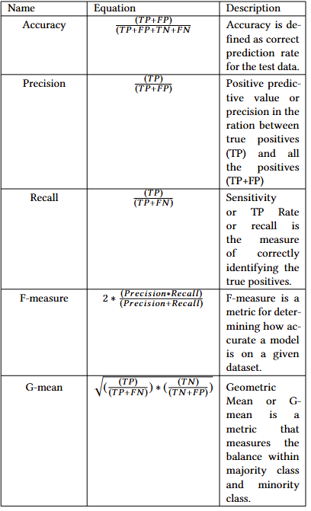
Reprinted from “Class Imbalance Problems in Machine Learning: A Review of Methods And Future Challenges” by Nazim Uddin Niaz, K.M. Nadim Shahariar, Muhammed J. A. Patwary, 2022.

Appendix B: Full Results of Prediction Model On 11 Datasets

Credit Card Approval Prediction: (Male: 37.81%, Female: 62.19%, IR Score: 1.6448)
A dataset of Applicants, where the original target label is application status (1 = approved, 0 = denied).
Credit Card Approval Prediction (Cleaned Version)
Dataset | Accuracy | F1 | Precision | G-Mean | TP | TN | FP | FN | Tuples
Original | 0.695 | 0.6826 | 0.6857 | 0.6462 | 866 | 2627 | 511 | 1022 | 25128
SMOTE | 0.7466 | 0.7466 | 0.7466 | 0.7464 | 2266 | 2401 | 774 | 810 | 31254
NearMiss | 0.6796 | 0.6794 | 0.6799 | 0.6796 | 1251 | 1332 | 568 | 650 | 19002
Combined | 0.7021 | 0.702 | 0.7022 | 0.7018 | 1682 | 1847 | 708 | 789 | 25128

Adult Income: (Male: 66.85%, Female: 33.15%, IR Score: 2.0164)
A census-based dataset used to predict whether an individual earns above or below a salary threshold, where the target label is income (1 = >50K, 0 = ≤50K).
https://www.kaggle.com/datasets/wenruliu/adult-income-dataset
Dataset | Accuracy | F1 | Precision | G-Mean | TP | TN | FP | FN | Tuples
Original | 0.7618 | 0.7595 | 0.7581 | 0.7223 | 5462 | 1980 | 1278 | 1049 | 48842
SMOTE | 0.7755 | 0.7754 | 0.7757 | 0.7752 | 5269 | 4859 | 1578 | 1354 | 65300
NearMiss | 0.7636 | 0.7634 | 0.7653 | 0.7641 | 2547 | 2399 | 886 | 645 | 32384
Combined | 0.7745 | 0.7743 | 0.7751 | 0.7742 | 3969 | 3597 | 1232 | 971 | 48842

Heart Disease: (Male: 67.99%, Female: 32.01%, IR Score: 2.1237)
A clinical dataset collected from patients at the Cleveland Clinic used to detect the presence of heart disease, where the target label is condition (1 = disease present, 0 = no disease).
https://www.kaggle.com/datasets/ritwikb3/heart-disease-cleveland
Dataset | Accuracy | F1 | Precision | G-Mean | TP | TN | FP | FN | Tuples
Original | 0.7869 | 0.797 | 0.8179 | 0.761 | 38 | 10 | 4 | 9 | 303
SMOTE | 0.7349 | 0.7349 | 0.7349 | 0.7302 | 25 | 36 | 11 | 11 | 412
NearMiss | 0.7692 | 0.7686 | 0.769 | 0.7659 | 17 | 13 | 5 | 4 | 194
Combined | 0.8197 | 0.8194 | 0.8231 | 0.8204 | 26 | 24 | 7 | 4 | 302

Credit Card Default: (Male: 39.63%, Female: 60.37%, IR Score: 1.5236)
A financial dataset of credit card clients in Taiwan used to predict payment default, where the target label is default payment (1 = defaulted, 0 = did not default).
https://www.kaggle.com/datasets/uciml/default-of-credit-card-clients-dataset?select=UCI_Credit_Card.csv
Dataset | Accuracy | F1 | Precision | G-Mean | TP | TN | FP | FN | Tuples
Original | 0.6018 | 0.4986 | 0.5735 | 0.508 | 3423 | 188 | 2218 | 171 | 30000
SMOTE | 0.6566 | 0.6534 | 0.6629 | 0.6567 | 2726 | 2031 | 1597 | 891 | 36224
NearMiss | 0.6074 | 0.6061 | 0.6082 | 0.6068 | 1597 | 1292 | 1060 | 807 | 23776
Combined | 0.5922 | 0.5922 | 0.5923 | 0.5922 | 1750 | 1803 | 1245 | 1202 | 30000

Cardiovascular Disease: (Male: 34.96%, Female: 65.04%, IR Score: 1.8606)
A medical dataset used to predict the presence of cardiovascular disease based on patient health indicators, where the target label is cardio (1 = disease present, 0 = no disease).
https://www.kaggle.com/datasets/sulianova/cardiovascular-disease-dataset
Dataset | Accuracy | F1 | Precision | G-Mean | TP | TN | FP | FN | Tuples
Original | 0.7224 | 0.6732 | 0.7452 | 0.6064 | 1290 | 8824 | 305 | 3581 | 70000
SMOTE | 0.8075 | 0.8033 | 0.8348 | 0.8065 | 5983 | 8724 | 447 | 3058 | 91060
NearMiss | 0.6916 | 0.688 | 0.7028 | 0.6929 | 2890 | 3879 | 954 | 2065 | 48940
Combined | 0.7703 | 0.767 | 0.7874 | 0.7708 | 4573 | 6211 | 758 | 2458 | 70000

Stroke Prediction: (Male: 58.6%, Female: 41.4%, IR Score: 1.4156)
A healthcare dataset used to predict whether a patient is likely to suffer a stroke based on lifestyle and clinical features, where the target label is stroke (1 = had stroke, 0 = no stroke).
Stroke Prediction Dataset
Dataset | Accuracy | F1 | Precision | G-Mean | TP | TN | FP | FN | Tuples
Original | 0.5832 | 0.5164 | 0.5628 | 0.5241 | 71 | 525 | 65 | 361 | 5109
SMOTE | 0.6503 | 0.6336 | 0.677 | 0.646 | 256 | 523 | 88 | 331 | 5988
NearMiss | 0.6064 | 0.6028 | 0.606 | 0.602 | 205 | 308 | 135 | 198 | 4230
Combined | 0.6282 | 0.6187 | 0.6445 | 0.6297 | 243 | 399 | 107 | 273 | 5108
Students Adaptability Level in Online Education: (Male: 55.02%, Female: 44.98%, IR Score: 1.2232)
predict the outcome of Students’ Adaptability Level Prediction in Online Education using Machine Learning Approaches, where the original target label is Adaptivity level
(Low, Moderate, High).
Students Adaptability Level in Online Education
Dataset | Accuracy | F1 | Precision | G-Mean | TP | TN | FP | FN | Tuples
Original | 0.6515 | 0.6508 | 0.651 | 0.6496 | 70 | 87 | 39 | 45 | 1205
SMOTE | 0.688 | 0.6879 | 0.6879 | 0.6878 | 94 | 89 | 42 | 41 | 1326
NearMiss | 0.6083 | 0.608 | 0.6098 | 0.609 | 68 | 64 | 47 | 38 | 1084
Combined | 0.6183 | 0.6177 | 0.6341 | 0.6262 | 76 | 73 | 60 | 32 | 1204

Lung Cancer Diagnosis: (Male: 52.43%, Female: 47.57%, IR Score: 1.102)
A medical dataset used to identify the presence of lung cancer based on patient symptoms and habits, where the target label is lung cancer (1 = cancer present, 0 = no cancer).
Lung Cancer
Dataset | Accuracy | F1 | Precision | G-Mean | TP | TN | FP | FN | Tuples
Original | 0.7097 | 0.7091 | 0.7144 | 0.7115 | 23 | 21 | 11 | 7 | 309
SMOTE | 0.8308 | 0.8305 | 0.8307 | 0.8286 | 30 | 24 | 6 | 5 | 324
NearMiss | 0.8136 | 0.8139 | 0.8184 | 0.8165 | 23 | 25 | 7 | 4 | 294
Combined | 0.7419 | 0.7419 | 0.7419 | 0.7417 | 24 | 22 | 8 | 8 | 308

Student Dropout Analysis and Prediction Dataset: (Male: 40.99%, Female: 59.01%, IR Score: 1.4398)
An educational dataset used to predict whether a student dropped out of higher education, where the target label is dropout (1 = dropped out, 0 = did not drop out).
https://www.kaggle.com/datasets/abdullah0a/student-dropout-analysis-and-prediction-dataset
Dataset | Accuracy | F1 | Precision | G-Mean | TP | TN | FP | FN | Tuples
Original | 0.6923 | 0.6923 | 0.6923 | 0.6419 | 21 | 69 | 20 | 20 | 649
SMOTE | 0.7273 | 0.7269 | 0.7275 | 0.7264 | 52 | 60 | 19 | 23 | 766
NearMiss | 0.6916 | 0.6919 | 0.6923 | 0.6893 | 32 | 42 | 17 | 16 | 532
Combined | 0.8 | 0.8 | 0.8 | 0.7992 | 48 | 56 | 13 | 13 | 648

Indian Liver Patient Records: (Male: 75.64%, Female: 24.36%, IR Score: 3.1056)
A clinical dataset from India used to predict whether a patient has a liver disease based on blood test results, where the target label is Dataset (1 = liver disease, 0 = no disease).
Indian Liver Patient Records
Dataset | Accuracy | F1 | Precision | G-Mean | TP | TN | FP | FN | Tuples
Original | 0.7265 | 0.6114 | 0.5278 | 0.4458 | 85 | 0 | 32 | 0 | 583
SMOTE | 0.8023 | 0.7959 | 0.8599 | 0.8097 | 85 | 57 | 35 | 0 | 882
NearMiss | 0.6491 | 0.6343 | 0.6633 | 0.6388 | 25 | 12 | 15 | 5 | 284
Combined | 0.7521 | 0.7438 | 0.8127 | 0.764 | 53 | 35 | 27 | 2 | 582

Student Performance Dataset (Male 47%, Female 53%, IR Score: 1.1123)
Student Performance Data was obtained in a survey of students' math course in secondary school, where the target label as discussed before is G3 (final grade, 0–20)
Student Performance Dataset
Dataset | Accuracy | F1 | Precision | G-Mean | TP | TN | FP | FN | Tuples
Original | 0.6582 | 0.6583 | 0.6587 | 0.6582 | 27 | 25 | 13 | 14 | 395
SMOTE | 0.7143 | 0.7133 | 0.7423 | 0.7273 | 29 | 31 | 6 | 18 | 416
NearMiss | 0.6133 | 0.6137 | 0.6144 | 0.6112 | 20 | 26 | 15 | 14 | 374
Combined | 0.6835 | 0.6904 | 0.7234 | 0.6984 | 21 | 33 | 18 | 7 | 394

Metrics Used
Accuracy measures the overall percentage of correct predictions out of all predictions made. While intuitive, it can be misleading when the target label is imbalanced — a model that always predicts the majority class can still achieve high accuracy.
Precision measures of all the samples the model predicted as positive, how many were actually positive. It reflects the model's reliability when it makes a positive prediction, penalizing false alarms.

F1 Score is the harmonic means of precision and recall, balancing both metrics into a single score. It is more informative than accuracy when classes are unevenly distributed in the target label.

G-Mean (Geometric Mean) is the geometric mean of sensitivity (true positive rate) and specificity (true negative rate. High G-Mean signals that the model is not biased toward predicting one class over the other. Importantly, while G-Mean is a model evaluation metric and not a direct measure of dataset balance, it is sensitive to the effects of balancing: when gender balancing shifts the training distribution, G-Mean captures whether that shift led to fairer predictions across both outcome classes.

TP, TN, FP, FN (True Positives, True Negatives, False Positives, False Negatives) are the raw counts behind all other metrics, showing exactly where the model succeeded and failed at the class level.

Appendix C: How SMOTE Works

SMOTE stands for Synthetic Minority Over-sampling Technique. The main idea is simple: instead of copying existing minority rows, SMOTE creates brand new rows that look realistic by blending pairs of existing ones.

Step 1: Pick a minority row
SMOTE starts with one row from the minority class. Call it point A. For example, in the diabetes dataset, point A might be a diabetic patient with these values: age=45, glucose=148, BMI=33.6.
Step 2: Find its k nearest neighbors
SMOTE looks at all other minority rows and finds the k most similar ones to point A. With k=5, it finds the 5 diabetic patients whose health measurements are most similar to patient A.
Step 3: Pick one neighbor randomly
From those 5 neighbors, SMOTE picks one at random. Call it point B. For example, point B might be: age=50, glucose=152, BMI=31.2.
Step 4: Create a new synthetic row
SMOTE picks a random spot on the straight line between point A and point B and creates a new row there. The formula is:
new row = A + t x (B - A)
where t is a random number between 0 and 1. If t = 0.4, the new synthetic patient looks like this:
age = 45 + 0.4 x (50 - 45) = 47 glucose = 148 + 0.4 x (152 - 148) = 149.6 BMI = 33.6 + 0.4 x (31.2 - 33.6) = 32.6
This new patient never existed in the original dataset, but every value is a blend of two real diabetic patients so it looks completely realistic.

Appendix D: How NearMiss works

Step 1: Look at every majority row
NearMiss goes through every single row in the majority class one by one.
Step 2: Measure its distance to the minority class
For each majority row, NearMiss finds its n nearest minority rows and calculates the average distance to them. With n=3, it finds the 3 closest minority rows and averages their distances. A low score means this majority row is very close to the minority class. A high score means it is far away.
Step 3: Rank and keep the closest ones
NearMiss sorts all majority rows by their score and keeps only the ones with the lowest scores, meaning those sitting closest to the minority boundary. It keeps removing until the majority count equals the minority count.
Step 4: Save what was removed
Every row that gets deleted is saved in a separate changes log CSV file so the user can see exactly which rows were removed.

Appendix E: What is the Jaccard Index?

The Jaccard index is a statistical measure used to quantify the similarity between two finite sets. As defined by its original formulation, it is computed as the ratio of the size of the intersection to the size of the union of two sets: J(A,B) = |A ∩ B| / |A ∪ B|, where the value ranges from 0, indicating no similarity, to 1, indicating identical sets (Jaccard, 1901). The index was introduced by Swiss botanist Paul Jaccard in his 1901 study of floral distribution across regions in the Alps and Jura mountains and has since become one of the most widely used similarity measures across multiple scientific disciplines.
In simple terms: if two sets share all the same elements, the score is 1.0. If they share nothing, the score is 0.0.

Appendix F: Why We Run SMOTE Before NearMiss in Combined method

The order in which the two methods run is not arbitrary. Running SMOTE first and NearMiss second is the established approach in hybrid sampling research.
A study published in Springer BMC Medical Informatics, which tested hybrid sampling on the Pima Indians Diabetes dataset — the same dataset we use — explicitly follows this order.
The authors state that "firstly, the SMOTE is used to over-sampling the datasets, so that the number of samples of the two classes is balanced. Then, ENN is used to under-sampling the over-sampled dataset to delete the noisy sample in the majority" (Zhang et al., 2022).

The reason this order makes sense is straightforward. SMOTE needs the original minority class to be intact when it creates synthetic rows. Running NearMiss afterward means it can see the full picture, including the new synthetic minority rows, and make better decisions about which majority rows are truly close to the minority boundary. Running it the other way around would mean NearMiss selects majority rows based on the original imbalanced minority class, and the boundary cleanup would be based on stale information that does not reflect the final balanced state.

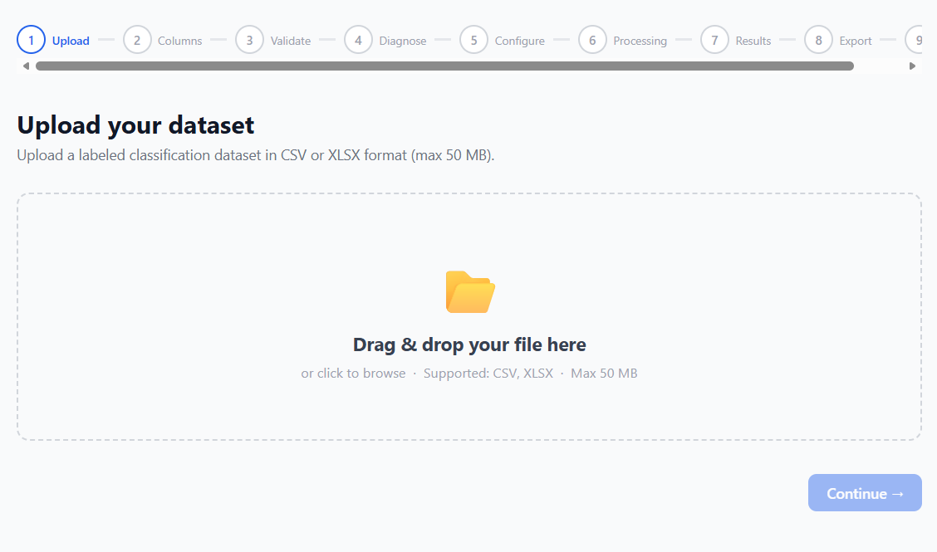
9. User Guide

1. Begin the first phase of the 9-step wizard by uploading the desired dataset.
You can upload the file by either dragging and dropping it directly in the site or by browsing your machine.
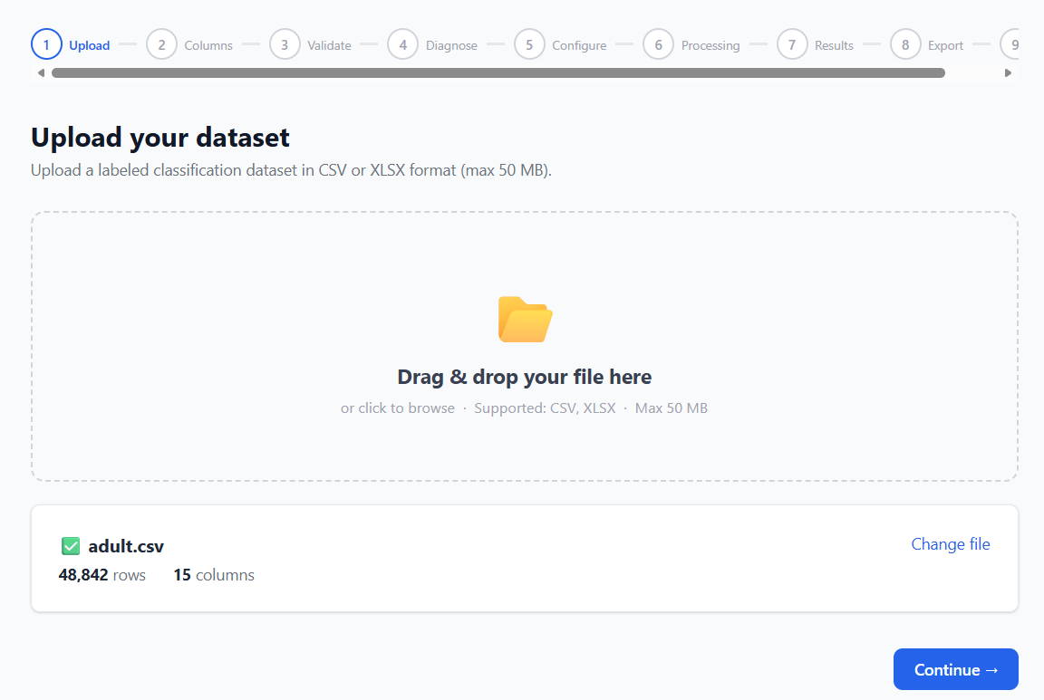
Note that ImbalanceKit can support CSV and XLSX file formats of up to 50 MB.

2. After successfully uploading the file, the system will display the name of the file and the number of rows and columns.
You can change the desired file by pressing “Change File”.
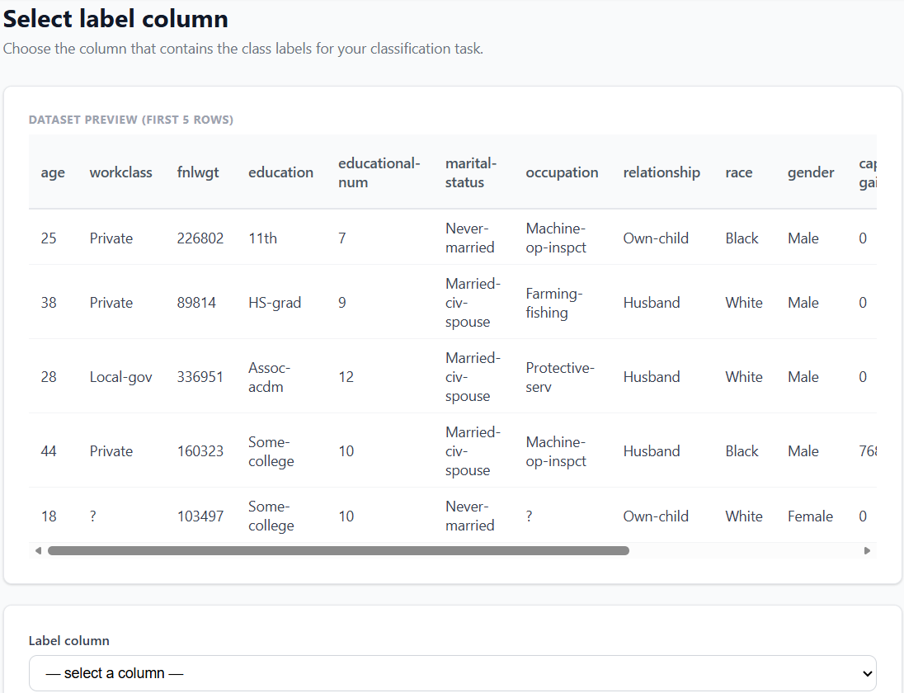
Proceed to step 2 after clicking continue.

3. Step 2 displays a preview of the dataset. Press “select a column” to choose the desired target label you wish to balance.
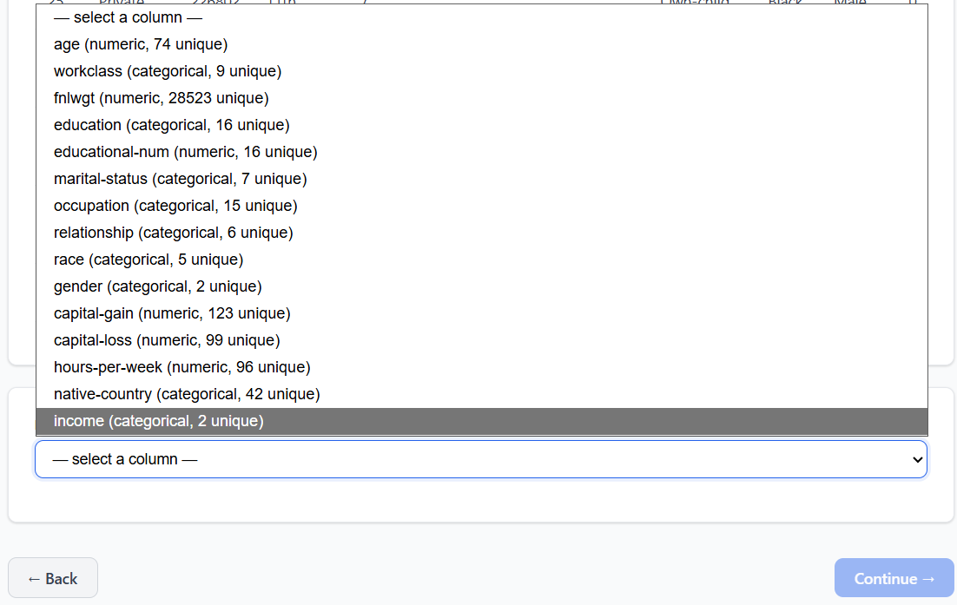

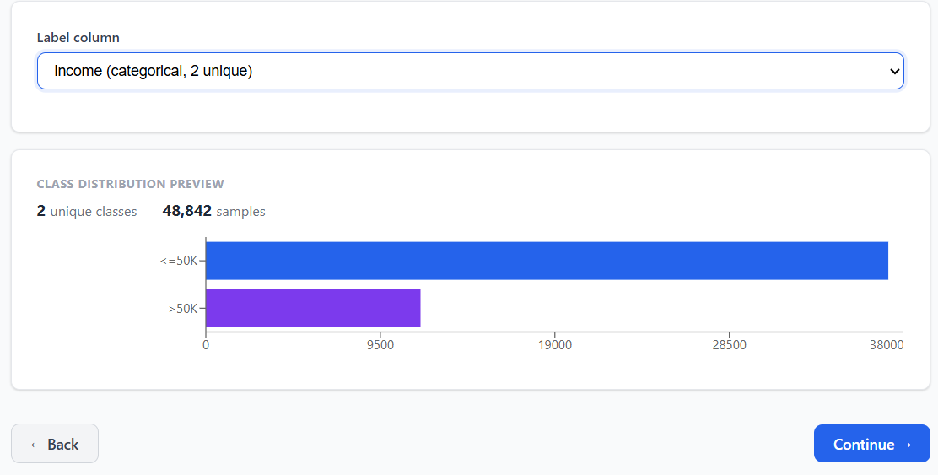

4. After choosing a label, the system will display a preview before the balancing.
Press “Continue” to proceed to step 3.
Note that you can always go back to the previous step by pressing the “Back” button.
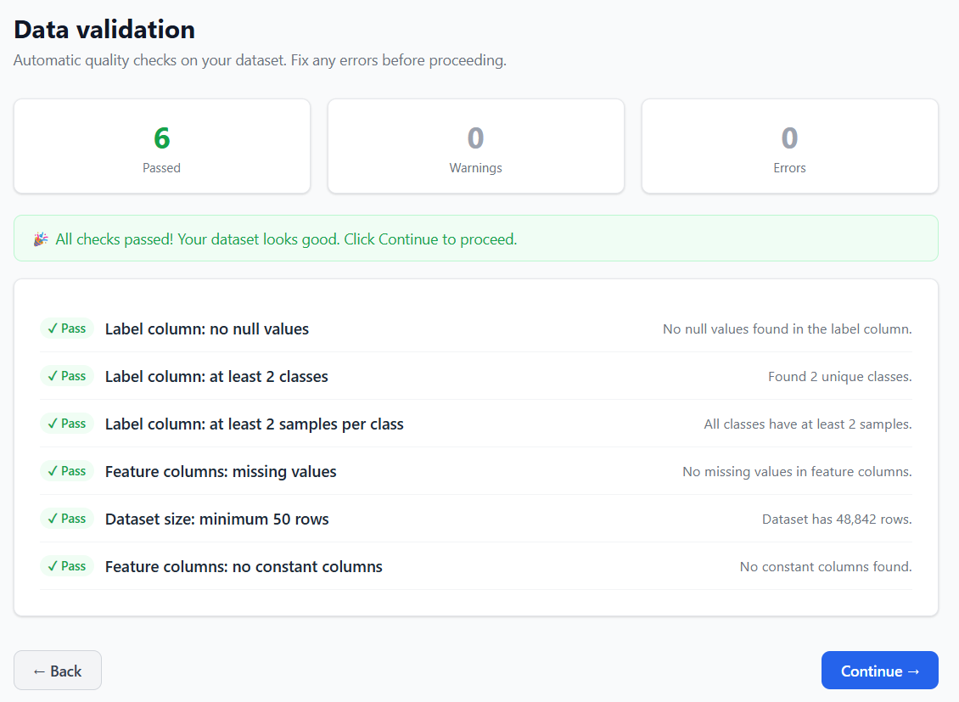

5. Step 3 validates that the dataset is safe to work with and displays the result to the user.
Press “Continue” to proceed to step 4.

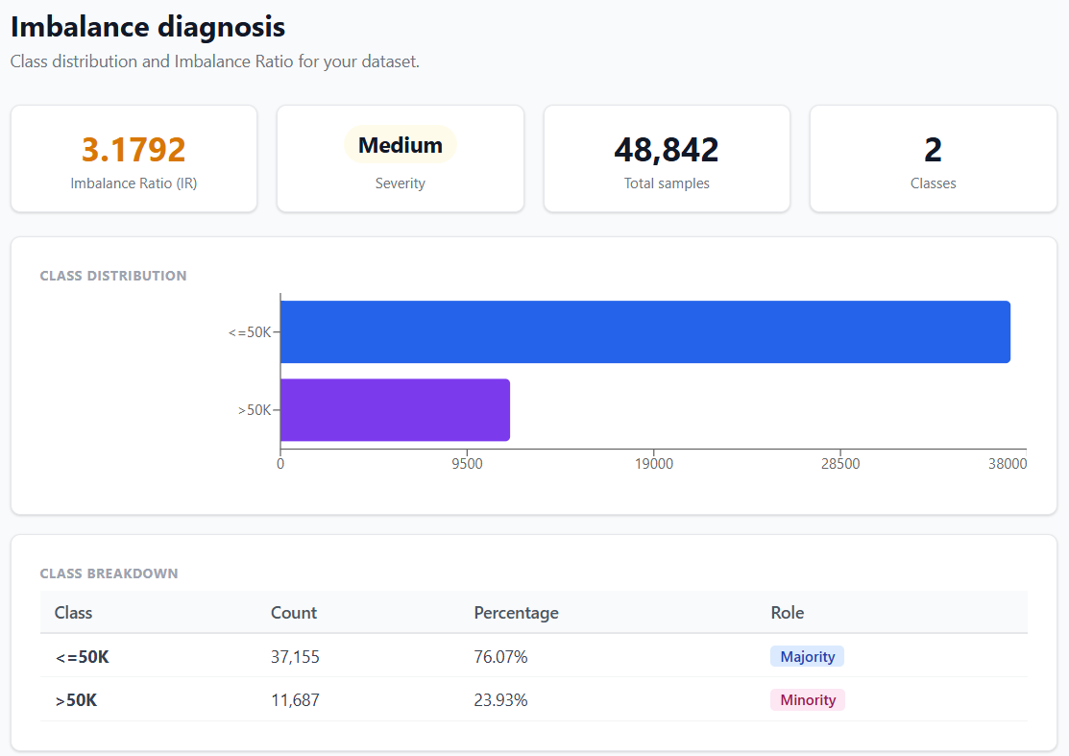
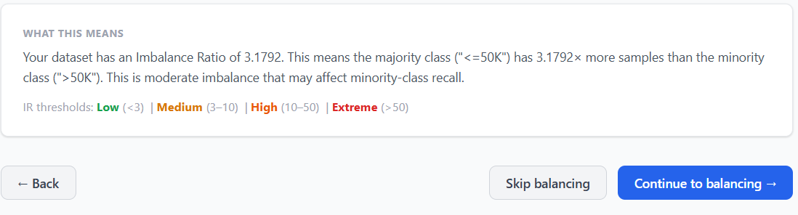
6. Step 4 displays information of how severe the imbalance in the selecting label, including the IR score, percentage of the majority/minority class and a legend to interpret the results.
Click “Continue to balancing” to proceed to step 5.

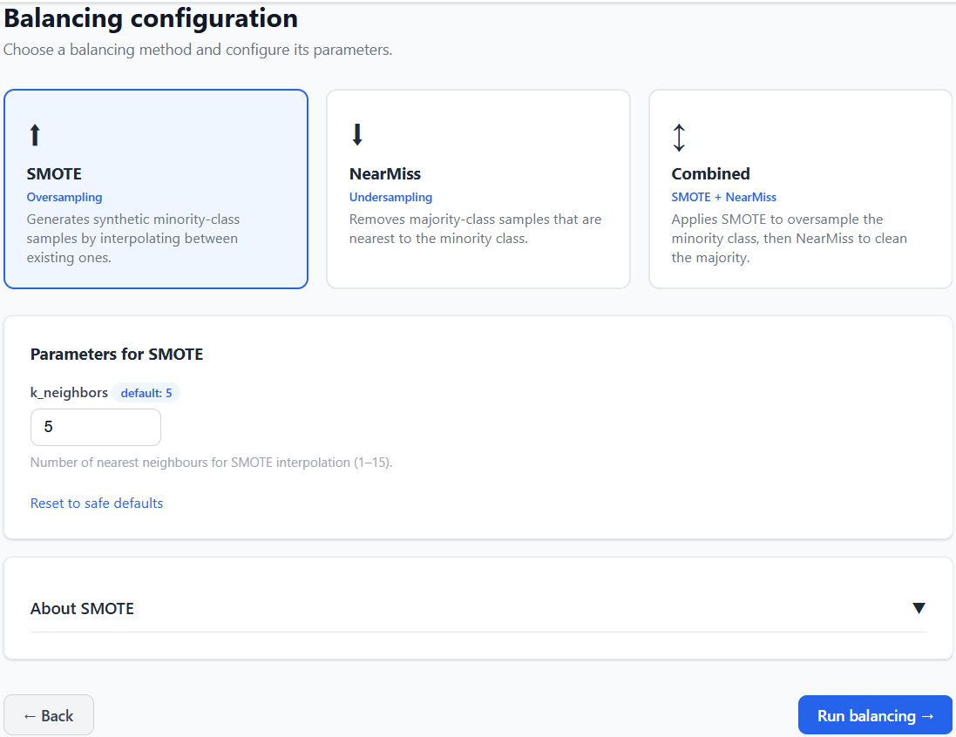

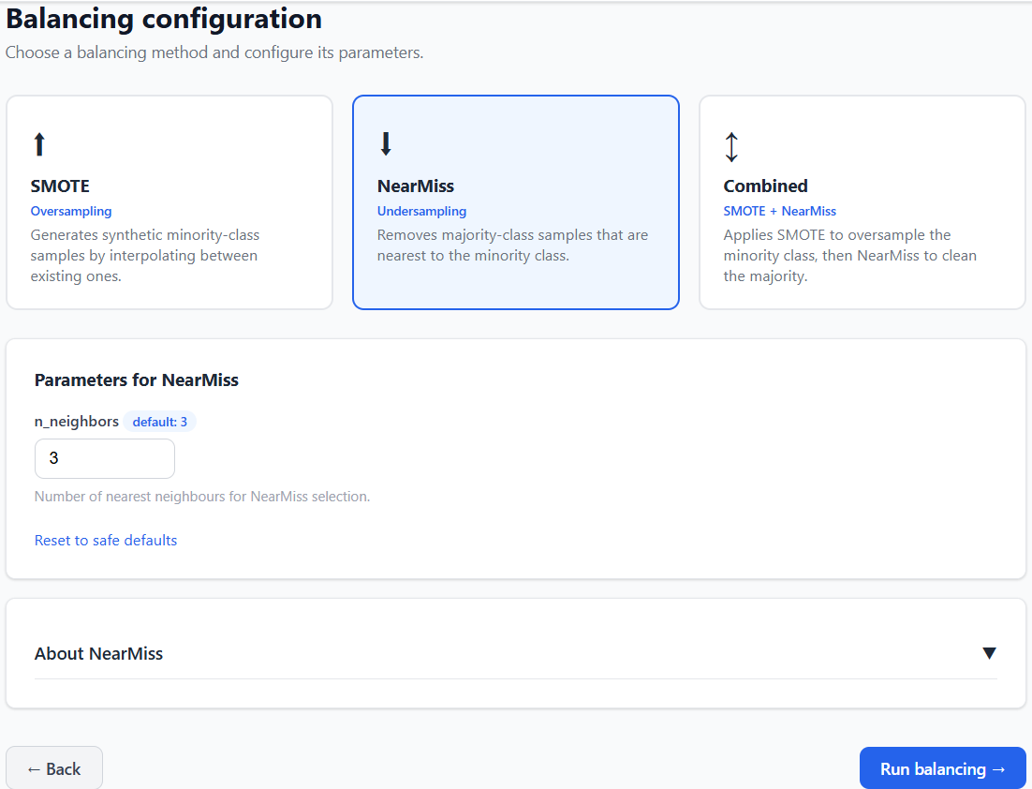

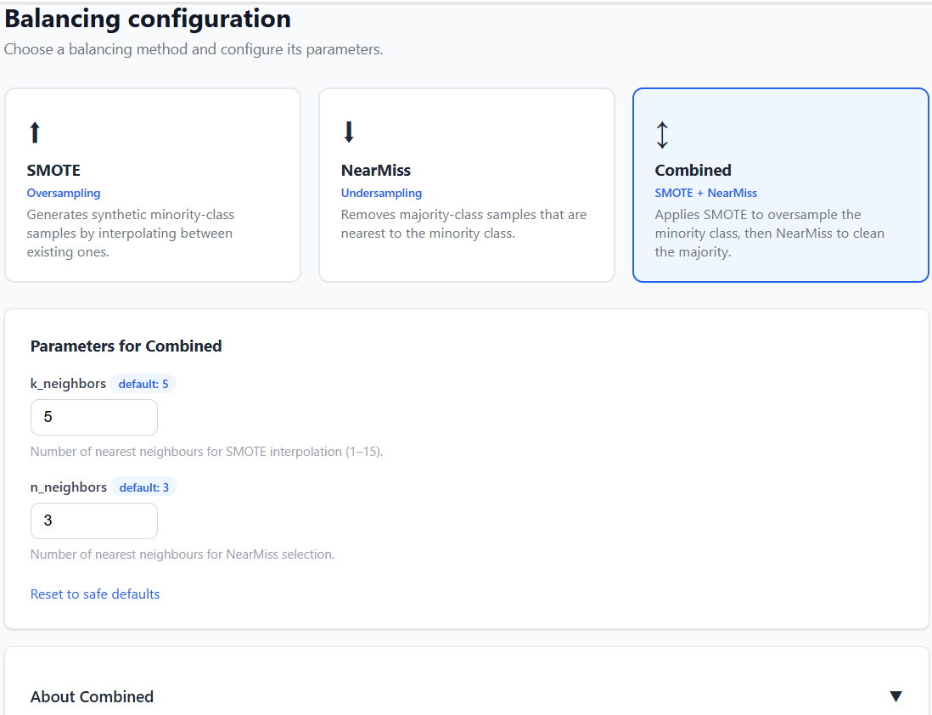

7. Select the desired balancing method by clicking one of the displayed options: SMOTE, NearMiss or Combined.
Note that parameters displayed for each method cannot be changed.
By pressing the “about arrow” you can read on how each method works.
Press the “Run Balancing” button to proceed to step 6 to process the request and step 7 to show the results.
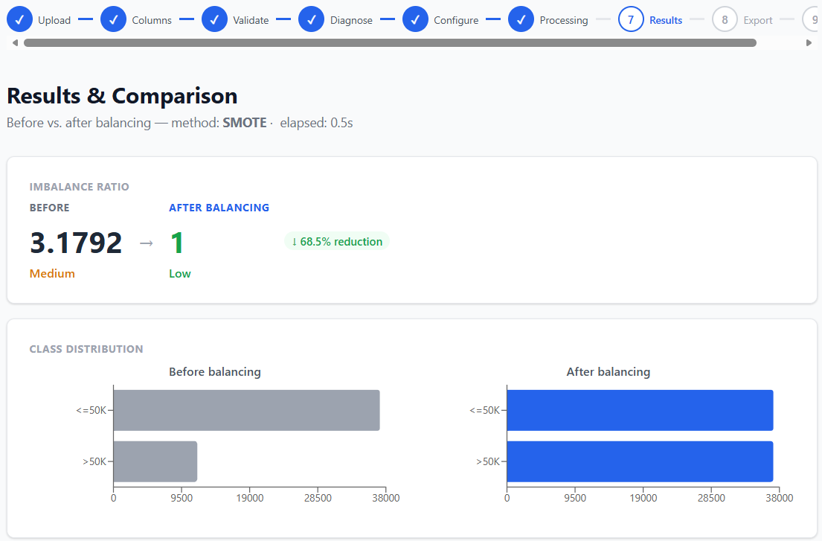

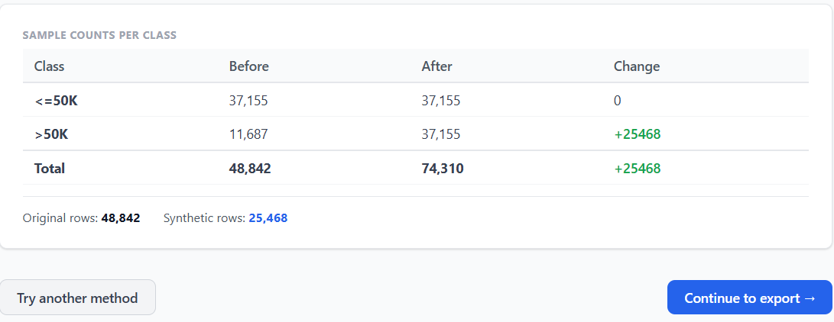
8. Step 7 displays the changes made to the dataset by the selected method in the previous step.
You can go back and select a different method by pressing “Try another method” button or continue to step 8 by pressing “Continue to export”.
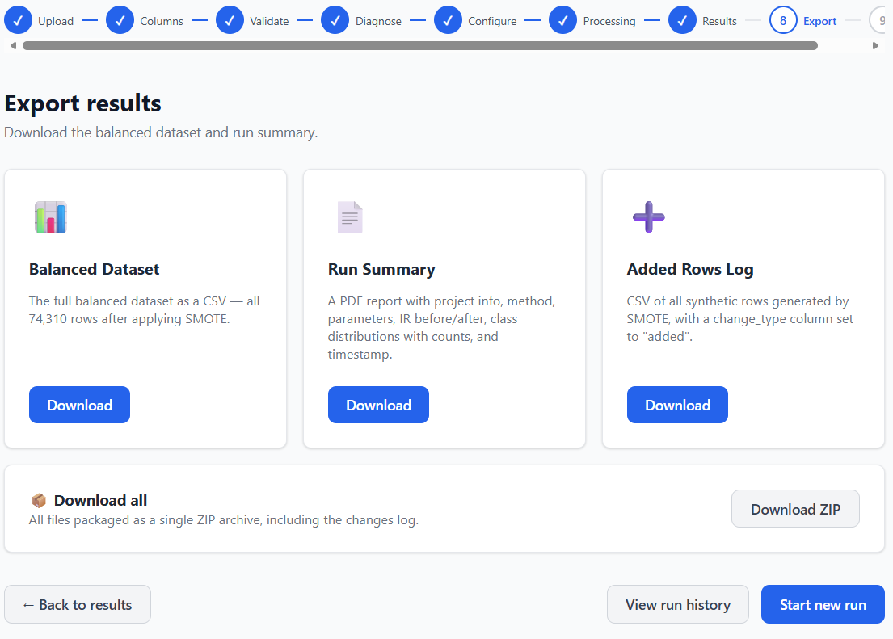
9. Step 8 displays the export results. Press “download” to either get the new balanced dataset, A summary of the changes made or log of the added rows to the dataset.
Note: The log changes in accordance to the method chosen.
SMOTE --- Added Rows Log
NearMiss --- Removed Rows Log
Combined --- Changes Log (shows the added and removed rows)
Click “Download ZIP” to download all three files all at once.

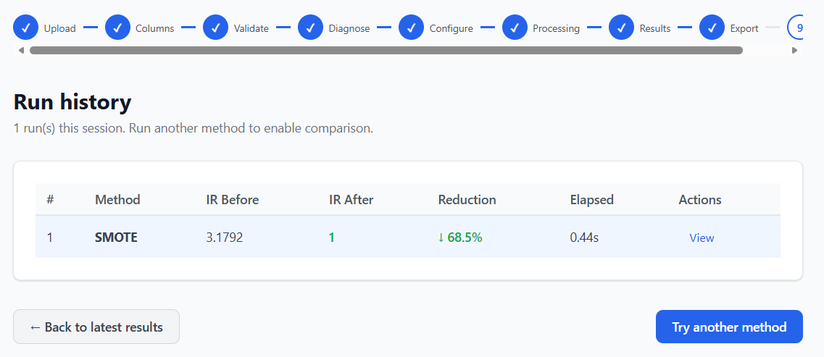
10. Clicking “View run history” will lead you to step 9 of the wizard, it displays a summary of the latest and previous runs.
Click “Try another method” to select a new balancing method.
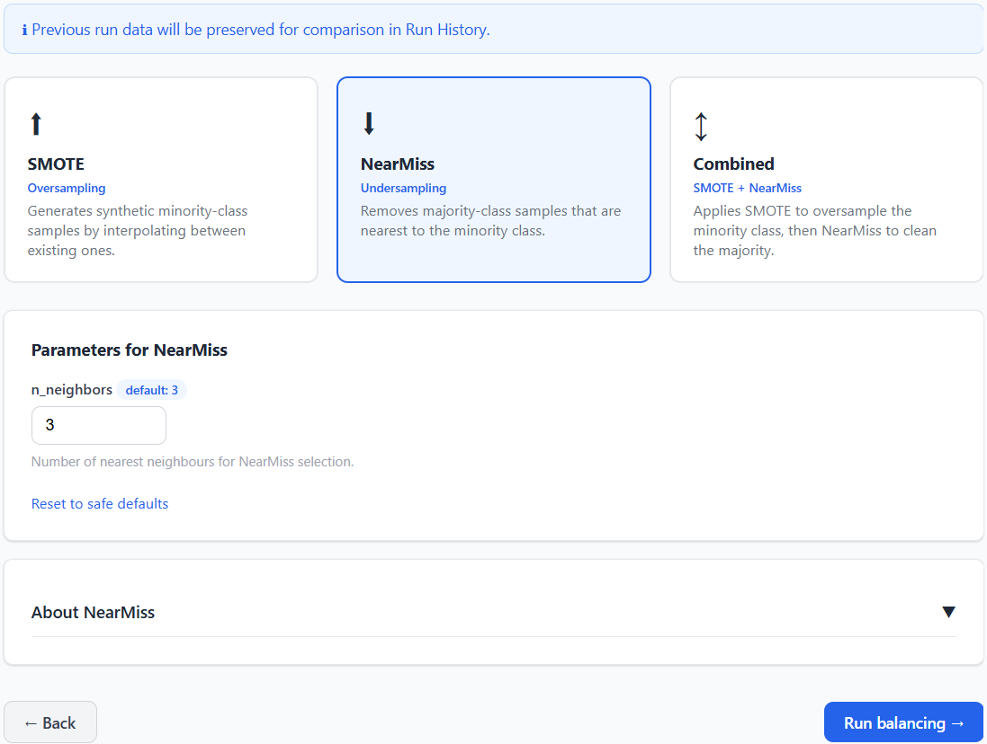
11. Select a new method and click “Run balancing”.
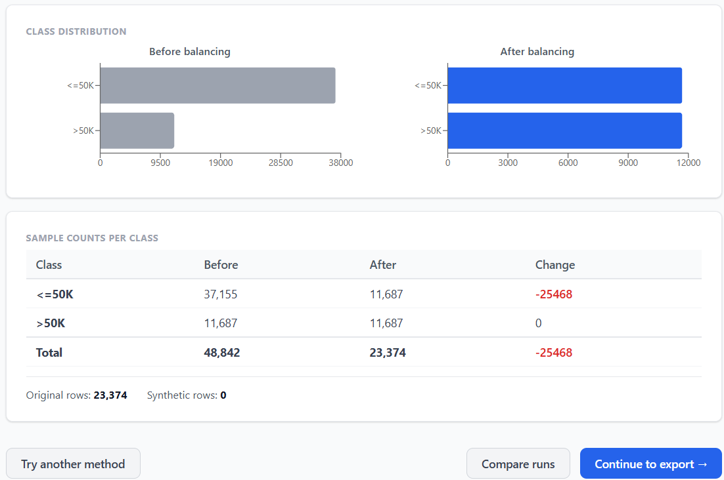

12. Now you can compare the results of both runs by clicking “Compare runs” before proceeding to export.
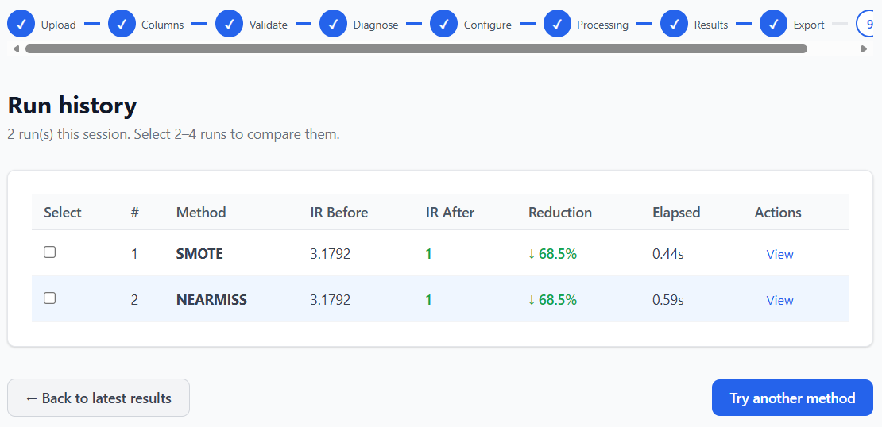
13. If you’re satisfied with the results, you can go back to the previous page by clicking “Back to latest results” and proceed to export or try another method.

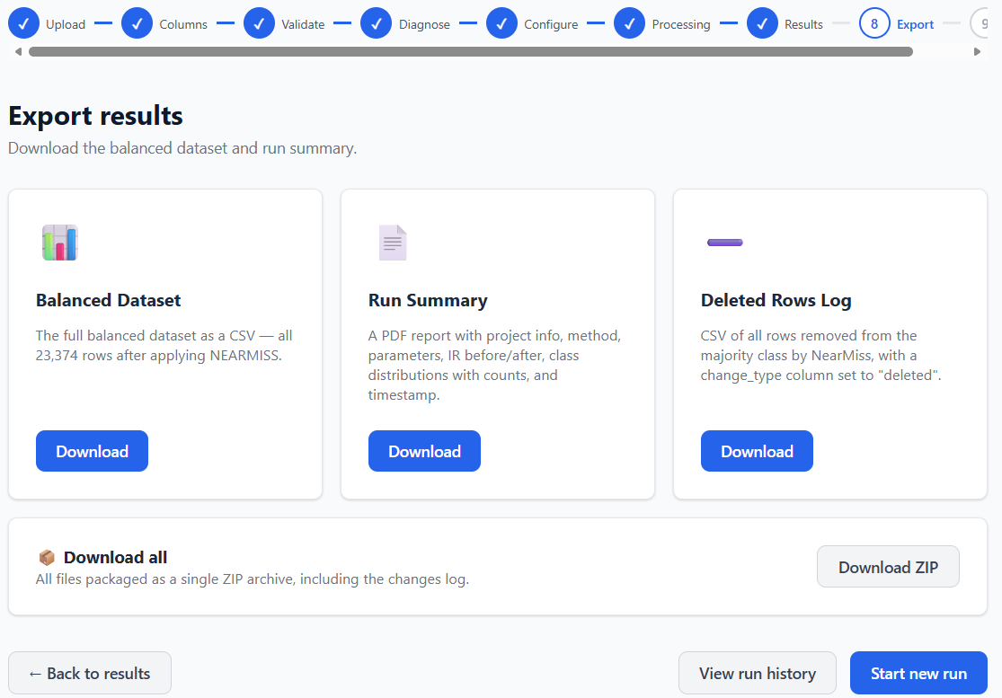
14. Export results screen is the same as the previous run with the first method but, as mentioned previously, the log changes accordingly.
Click “Start new run” button to reset the system to the first step and choose a new dataset to balance.

10. Maintenance Guide

System Overview for Maintenance

ImbalanceKit is built on two separate technologies that must both be installed and running for the system to function. The backend is written in Python using the FastAPI framework and relies on several Python libraries for data processing and balancing, all listed in the requirements.txt file in the backend/ folder. The frontend is a React application built with Vite, which requires Node.js to run. Node.js is a JavaScript runtime that also includes npm, the package manager used to install the frontend dependencies. To run the system locally, the user will need Python 3.12 or higher and Node.js 18 or higher installed on their machine. Neither a database nor an internet connection is required during operation, all processing is done in-memory on the local machine.

Architecture Overview

ImbalanceKit consists of two independently running components that must both be active for the system to function:

Backend: A Python FastAPI server that handles all data processing, balancing logic, and file export. It runs locally on port 8001 and exposes a REST API consumed by the frontend.

Frontend: A React application built with Vite that serves the user interface. It runs locally on port 5173 and communicates with the backend via HTTP requests.
Both components run on the same machine and do not require an internet connection or external database during operation.

Installation
1. Clone the Repository
git clone https://github.com/Niv0902/Niv-and-Dani---Data-Imbalance-Testing-and-Handling-System.git
cd Niv-and-Dani---Data-Imbalance-Testing-and-Handling-System

2. Install Backend Dependencies
cd backend
python -m pip install -r requirements.txt

3. Install Frontend Dependencies
cd frontend
npm install

Running the System

Start the Backend (from the backend/ folder):
python -m uvicorn main:app --reload --host 127.0.0.1 --port 8001
Start the Frontend (from the frontend/ folder):

npm run dev
Alternatively, double-click start_backend.bat and start_frontend.bat from the project root (Windows only).

Once both are running, open a browser and navigate to:
http://localhost:5173
Both terminal windows must remain open while using the system.

